***A Mini Project Synopsis on***

FARMERS ASSISTANCE

**S.E. - Data Science**

**Submitted By**

# Soham Dewrukhkar(22107054) Sahil Gorde(22107035)

**Varad Chaudhari(22107053) Dhanraj Bacche(22107056)**

**Under The Guidance Of**

**Prof. Sarala Mary**



**DEPARTMENT OF CSE (DATA SCIENCE)**

A.P.SHAH INSTITUTE OF TECHNOLOGY

G.B. Road, Kasarvadavali, Thane (W), Mumbai-400615 UNIVERSITY OF MUMBAI

**Academic Year: 2023-24**

# CERTIFICATE

This is to certify that the Mini Project report on FARM ASSISTANCE has been submitted by Soham Dewrukhkar(22107054), Sahil Gorde(22107035), Varad Chaudhari (22107053), and Dhanraj Bacche (22107056) who are a Bonafide students of A. P. Shah Institute of Technology, Thane, Mumbai, as a partial fulfillment of the requirement for the degree in **CSE(DATA SCIENCE)**, during the academic year **2023-2024** in the satisfacto22

**Prof. Sarala Mary** Guide

**Prof. Anagha Aher** **Dr. Uttam D.Kolekar**

Head Department of Information Technology Principal

External Examiner(s) 1.

2.

Place: A.P.Shah Institute of Technology, Thane Date:

### TABLE OF CONTENTS

1. Introduction. 1
   1. Purpose 1
   2. Objectives. 1
   3. Scope 2
2. Problem Definition 3
3. Proposed System 4
   1. Features and Functionality 4
4. Project Outcomes 7
5. Software Requirements 8
6. Project Design 9
7. Project Scheduling 15
8. Conclusion. 16

References Acknowledgement

# Chapter 1

## Introduction

The “Farm Assistance” has been developed to override the problems prevailing in practicing manual system . This software is supported to eliminate and in some case reduce the hardship faced by farmers. This application will try to reduce the hardships of farmers as much as possible. Thus it helps users in better utilization of resources.

The user, whether big or small , has challenges to overcome and manage the information of Crops , Farm, Insecticides, and Pesticides,So we designed a marketplace and information resource software for farmer. This is designed to help sell their goods at best price possible and for them to ge a bit of information about agriculture.

### Purpose :

The purpose of Farm Assistance is to automate the existing manual system by the help of computerized equipment and full fledged computer software, fulfilling their requirements so that their valuable data can be stored for a longer period with easy access and manipulation for the same. The required software and hardware are easily available and easy to work with.

Farm Assistance , as described above , can lead to error free , secure, reliable and fast management system. It can assist the user to concentrate on their other activities rather than to concentrate on record keeping. The user can maintain computerized records without redundant entries. That means that one need not be distracted by information that is not relevant while being able to reach the information. Basically, the project describes how to manage for good performance and better services for users.

* 1. **Objectives:**

The main objective of the project of the our farm assistance is to provide farmers with a marketplace to directly reach to customers. The project is totally built at the farmer and customer end and thus gives farmer and customer guaranteed access. The purpose of the project is to build an application program to eliminate the manual work for selling the crops in which most of the farmers have no expertise due to which they are unable to sell their good quality yields and sometimes lack information.

### Scope:

* + 1. **Farmers Market :** The Farmer's marketplace is a massively untouched and unorganized market, which only one or two companies have tapped.
    2. **Government and Policy Support:** Governments and agricultural agencies can use FMS data to formulate policies, allocate resources, and support farmers in achieving national food security and economic goals.
    3. **Startups and Entrepreneurship**: Entrepreneurs can explore opportunities to develop new FMS platforms, applications, and solutions to address specific challenges in agriculture.

2. **Problem Statement**

* **Limited Market:** Limited access to up-to-date market information is a prevalent challenge faced by practitioners of conventional agricultural techniques. The absence of real-time data hampers the ability to make informed decisions regarding crop sales, often leading to the unfortunate consequence of underselling agricultural produce at prices significantly below their actual market value.
* **Reduced Competitiveness:** Within the context of a highly competitive agricultural environment, agricultural enterprises that lack access to a contemporary marketplace infrastructure may encounter formidable difficulties in maintaining parity with technologically proficient counterparts.

**3. PROPOSED SYSTEM**

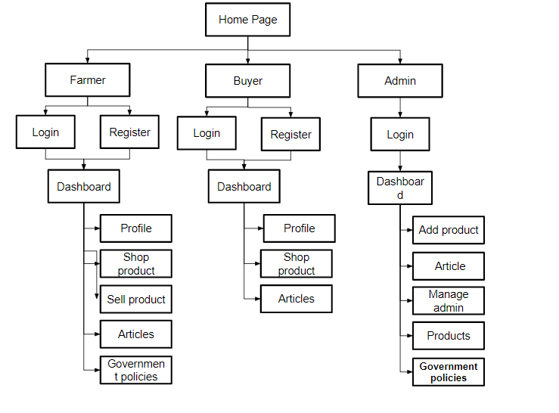

**3.1 Features & Functionality**

* **Market Linkages:** Endeavor to empower farmers by establishing robust connections with diverse market stakeholders, encompassing local purchasers, wholesale distributors, international exporters, and various agribusiness enterprises.
* **Providing Information:** Offering insights on the most recent government policies and up-to-the-minute news articles pertaining to the agricultural sector.
* **Direct To Consumer** : Facilitating direct-to-consumer (DTC) relationships in agriculture represents a transformative paradigm shift that bestows myriad advantages upon farmers. One of the paramount benefits is the empowerment of farmers to establish a direct and unmediated connection with consumers, affording them the autonomy to vend their agricultural produce at prices of their own discretion.
* **Low Cost High Quality:** Empowering Consumers with Affordable Excellence: Discerning buyers now have the opportunity to access superior products directly from the source, elevating quality while optimizing costs.

**4. Project outcomes:**

* **Improved Farm Efficiency:** Enhancing Agricultural Efficiency: Farm Assistance systems offer a sophisticated solution to optimize agricultural operations, effectively automating routine tasks, thereby fostering a substantial improvement in overall operational efficiency.
* **Market Access:** Access to the consumer market directly empowers farmers with the autonomy to establish competitive pricing strategies for their agricultural yields, as opposed to being subject to price determinations imposed by intermediaries. This direct market access not only affords farmers greater control over their product's value but also enables them to engage in price negotiations that reflect the quality, uniqueness, and demand for their produce.

**5. Software Requirement**

1. **Java Development Kit Version 20**
2. **MYSQL 8.0 CE**
3. **Net beans Apache Version 19**

# CHAPTER 6

## Project Design:-

### User Interface Design:-

Create wireframes and prototypes for the Graphic User Interface (GUI). Design an intuitive and user-friendly layout for adding product, buy/sell, and user profiles. Use responsive design principles to ensure compatibility with various devices and screen sizes. Choose a color scheme and typography that align with the website's branding.

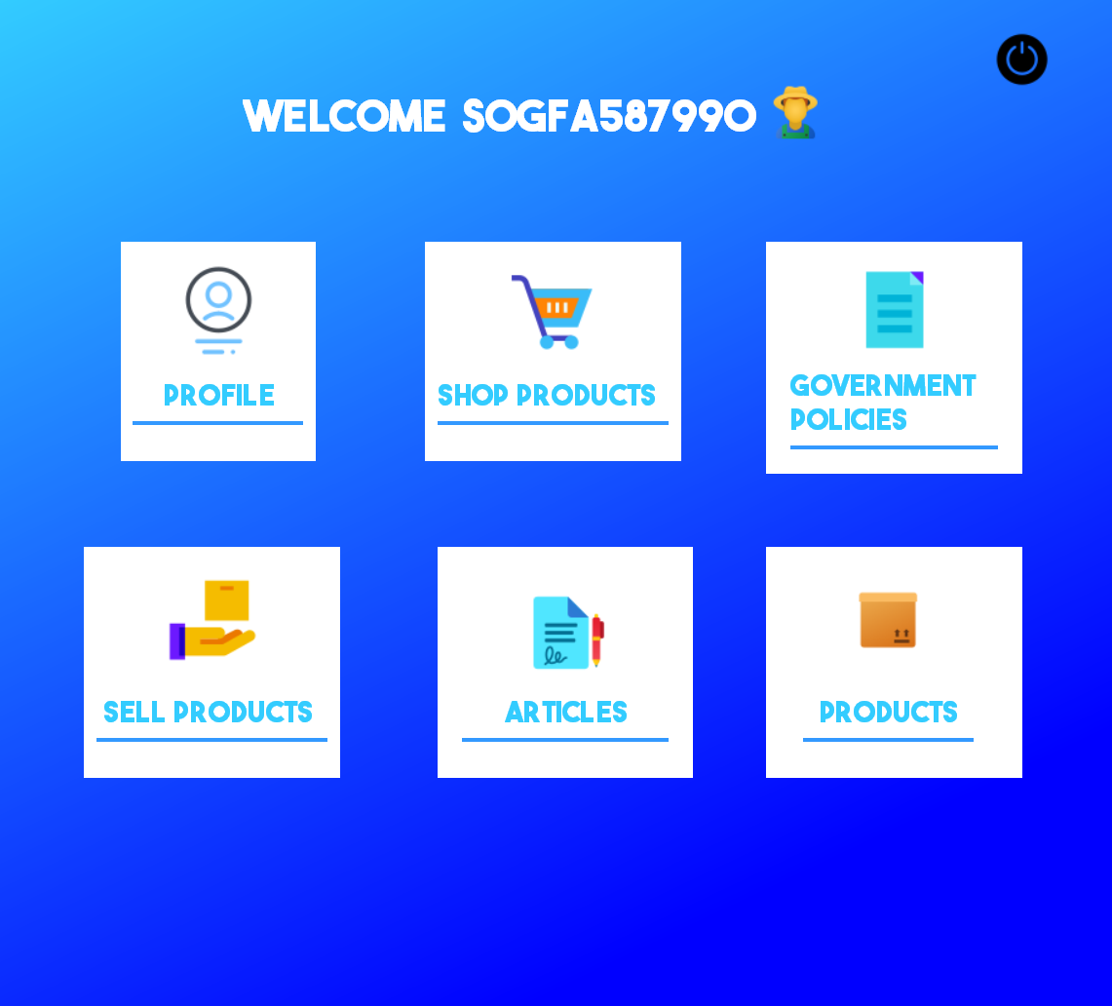

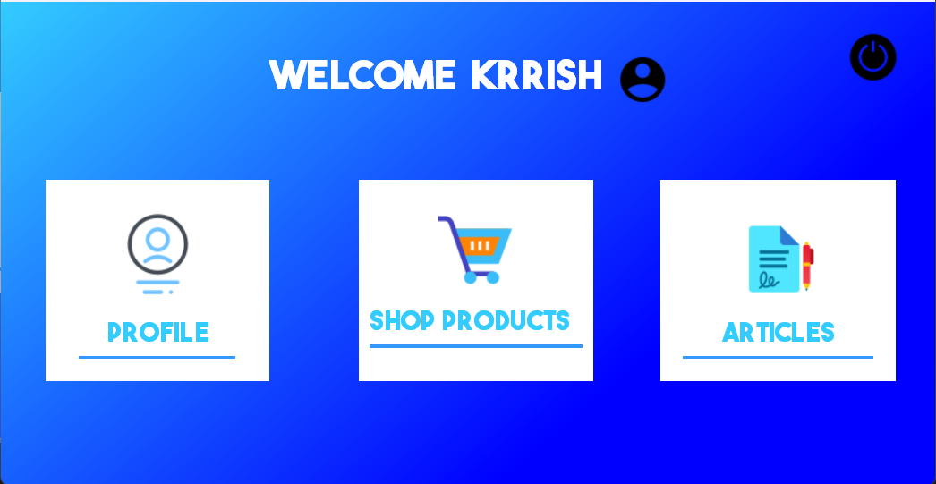

### Database Design:-

Identify the data entities required, such as Users, Products, News and Blog, Admin, and Government Policies. Choose an appropriate database management system (e.g., MySQL, PostgreSQL) and design the database schema. Implement normalization techniques to ensure data integrity.

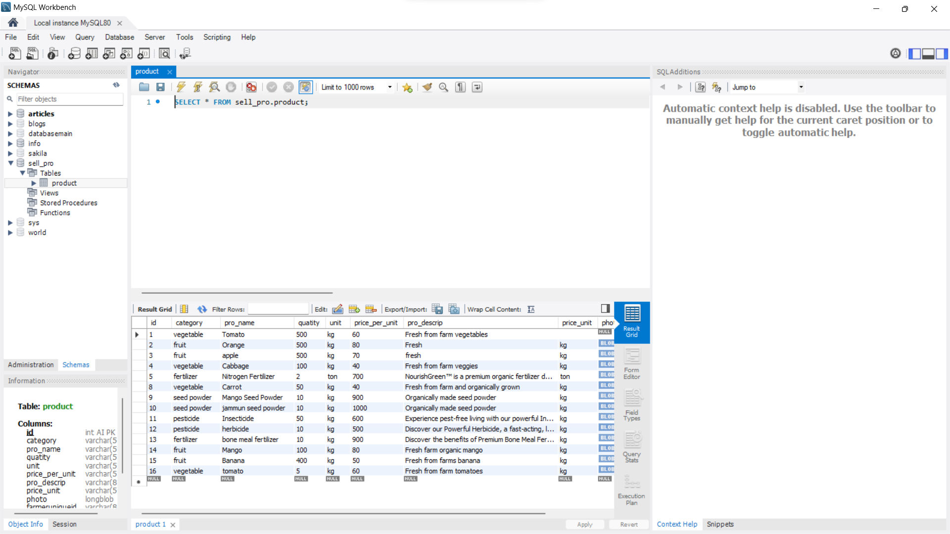

### Product Added:-

Implement features for adding products on the platform. Allow administrators to verify products. Provided the ability to add images to the panel.

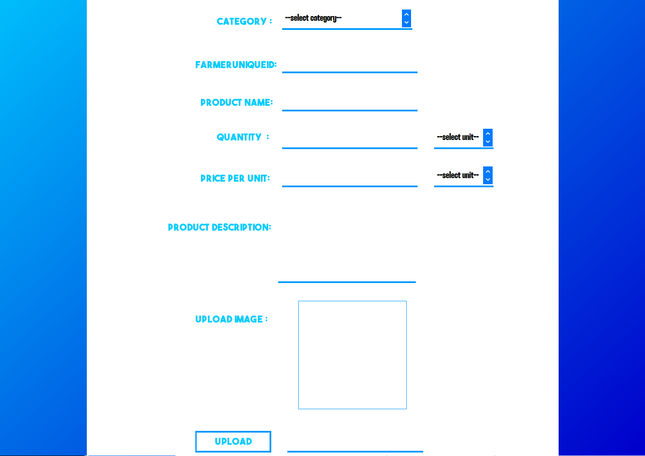

# CHAPTER 7

**Conclusion:-**

In conclusion, the Farmers Marketplace platform stands as a transformative force in reshaping the world of agriculture and local food distribution. This innovative digital solution not only addresses the longstanding challenges and inefficiencies associated with traditional farming and market practices but also ushers in a new era of interactive, data-driven, and sustainable agricultural experiences.

With features tailored to streamline the management of farmer markets, promote local and sustainable farming practices, and provide consumers with real-time access to fresh, locally sourced products, this platform offers a holistic solution to the evolving needs of modern agriculture. By ensuring transparency in the supply chain, fostering community engagement through educational programs and farmer profiles, and expanding access to fresh produce through an online marketplace, the Farmers Marketplace represents a significant advancement in the realm of sustainable farming and local food distribution.

As technology continues to influence the agricultural landscape, the Farmers Marketplace platform is poised to play a pivotal role in redefining the way we farm, connect with local farmers, and access fresh, healthy food, making it an invaluable asset for farmers, consumers, and communities alike.

## Project Scheduling Template

|  |  |  |  |
| --- | --- | --- | --- |
| **Sr. No** | **Group Member** | **Time duration** | **Work to be done** |
| **1** | Soham Dewrukhkar, Sahil Gorde, Varad Chaudari,  Dhanraj Bacche | 1st week of August | Group Formation, Finalization of the Topic, Making the paper prototype of the project. |
| 3rd week of August | Designing the Graphical User Interface(GUI) |
| **2** | Soham Dewrukhkar, Sahil Gorde, Varad Chaudari,  Dhanraj Bacche | 1st week of September | GUI’s Connectivity |
| **3** | Soham Dewrukhkar, Sahil Gorde, Varad Chaudari,  Dhanraj Bacche | 2nd week of September | Creating the database |
| **4** | Soham Dewrukhkar, Sahil Gorde, Varad Chaudari,  Dhanraj Bacche | End of October | Database Connectivity, Program Implementation |

## References

<https://youtu.be/Fj5y_intc5o?si=JzBLgdumMygsYqwi>

<https://youtu.be/wRd_ZbG1uE0?si=EbJpQ3lS2z9r5hWf>

<https://youtu.be/-41Fe0T-I9E?si=D0dUeBitmbwXTebE>

[https://youtu.be/y8KnCBRzTnw?si=Ga7_aQ0ZNjfnC](https://youtu.be/y8KnCBRzTnw?si=Ga7_aQ0ZNjfnCBRZ)

## ACKNOWLEDGEMENT

This project would not have come to fruition without the invaluable help of our guide

**Prof.Sarala Mary**. Expressing gratitude towards our HoD, **Prof.Anagha Aher**, and the Department of Information Technology for providing us with the opportunity as well as the support required to pursue this project. We would also like to thank our teacher Ms. Poonam Pangarkar who gave us her valuable suggestions and ideas when we were in need of them. We would also like to thank our peers for their helpful suggestions.